LTWeb Operation Manual

User

Version 1.2

October 27, 2015

Don Bellenger

[mobile1@uisdesign.com](mailto:mobile1@uisdesign.com)

240-426-1589

LTWeb – Version 1.2

**Overview of Operation**

1 Overview of LTWeb 3

2 Overview of LTWeb Operation – Client User 6

2.1 How Do I Get Started 6

2.2 Home Screen 6

2.3 Menu Options 7

3 User 8

4 Filing 10

5 RentalUnit – A Good Example of the LTWeb Controls 11

5.1 Grouping Records 11

5.2 Searching 11

5.3 Selecting 12

5.4 Operating on a Record and Going to Selected 12

5.5 Sorting 12

5.6 Initiating a Suit 13

5.7 Editing 14

6 History 15

7 Transaction 16

8 Task 19

8.1 Complaint Snapshot for a Rental Unit 20

8.2 Warrant Snapshot for a Rental Unit 21

8.3 Transactions Report 22

# Overview of LTWeb

What is it?

LTWeb is an Internet-based system that allows an LTWeb user to maintain an inventory of rental units, and periodically sue tenants for non-payment of rent.

LTWeb is operated by a legal firm, and is specifically maintained by that firm’s LTWeb Firm Administrator. The firm uses LTWeb to support several of its “Landlord/Tenant” Clients, each of whom are in turn managing one or more properties, each of which has several rental units, each of which has one or more tenants. Each Client will have an LTWeb user who enters changes to the Client’s inventory of rental units, including the list of tenants in each rental unit.

An LTWeb Firm Administrator can

* Create LTWeb user accounts
* Generate Forms for Court
  + Warrants
  + Complaints
* Generate Reports for Court
  + Docket Report
  + Dismissal Report
* Generate “helper” spreadsheets for EFiling
  + Complaints
  + Warrants
* Generate other reports to control the system
  + Transaction Report for a Filing
  + History for Tenants
  + Complaint Snapshot
  + Warrant Snapshot
* Track Case Numbers and Court Dates received from the courts, and publish the information to LTWeb Users, and to subsequent Docket, Dismissal and other reports.
* Perform LTWeb User operations on behalf the firm’s LTWeb client users.

An LTWeb User can

* Add, Update, or Delete rental units, thereby maintaining the user’s client’s list of rental units
* Request that the tenants in a unit be sued for non-payment of rent
* Generate various reports to help in these tasks.
* Transaction Report for a Filing
* History for Tenants
* Complaint Snapshot
* Warrant Snapshot

Benefits of LTWeb Operation

With LTWeb, procedures required to initiate and process suits are streamlined.

* Client Users maintain their inventory of rental units, tenants, and suit requests at their own workstations, with these results.
  + No need to assemble a list, and send it to the law firm.
  + Court Preparation
    - Up until 3 pm the day before a court date, a Client User can make changes in LTWeb – using the Transaction Menu Option to edit Transactions - reflecting **payments, partial payments, amended amounts, tenants vacating**, etc.
    - The Client User checks **Judgement** to indicate they are going forward with a Judgement, or clicks **Dismiss** to request that the case be dismissed.
    - The Client User should notify the Firm Administrator by phone or email when all changes are complete. The Administrator can then immediately print a new Docket and a new Dismissal Report, to interact with the Court.
  + No need for a Client to review a separate list coming back from the law firm, for errors.
  + Changes can be entered over time, and a transaction report generated at will to see the “suit list”.
  + Reduction in pressure.
  + Reduction in errors.
* Since LTWeb is based in a secure, off-site location
  + Reduced risk from catastrophic failure at law firm (fire, flood, break-in, staff issues).
  + Reduced risk, since many different workstations can access the database.
  + Automatic nightly backup of database.
  + Redundant power, redundant connectivity to the Internet.
  + Automatic upgrades to underlying hardware and software (operating system, database system, application development environment).

# Overview of LTWeb Operation – Client User

## How Do I Get Started

Log in with your User Name and Password as provided by the Firm Administrator.

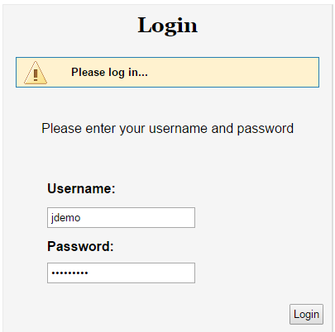

Figure 1

You will be presented with a simple Home Screen, with options to go to various sections of the system. These are described on the next page. Generally, you click on the options during your LTWeb Session, which ends when you click Logout.

**Note: There is a 30-minute inactivity timeout on your session. If LTWeb sits idle for 30-minutes, you will have to log in again.**

## Home Screen

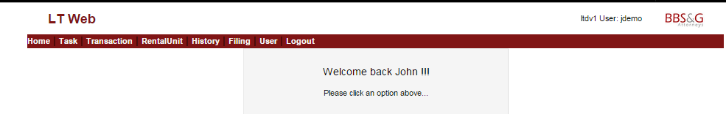

Figure 2

## Menu Options



Figure 3

**Home** – presents the screen above. This option is hardly ever selected.

**Task** – presents links for viewing various reports.

**Transaction** – shows the status of suit requests for the selected Filing. Here you enter changes since a suit was initiated (payments, etc.) **To be clear**, an action starts as a suit request when a user clicks “Sue” for a rental unit. An action may be dismissed, or simply deleted if it was a mistake in data entry. An Action may become a case when it is assigned a court date and case number.

**RentalUnit** – presents the interface for maintaining the inventory of units, and for initiating an Action (suit). To maintain a suit list, an LTWeb Client will spend most of the time in the **RentalUnit** option and the **Transaction** option.

**History** – shows the suit history of the currently-selected rental unit.

**Filing** – shows a list of Filings for your property, with the most current on at the top. A Filing is a collection of cases (suits) associated with a particular court date. Only one Filing can be open for new suits at a time. When you log in, you should click this option just to review “where you are”. A Filing is closed by the Firm Administrator when the Filing is used to generate Complaints to send to court. The next time you request to sue a tenant, a new Filing is automatically opened for you. You may have one Filing open for new suits, but select an older Filing in order to report on suits that are still being processed in that older Filing. If you then request a suit in the RentalUnit area, you will be brought back to the open Filing.

**User** – allows you to maintain your personal information, set your password, and set options such as “verbose” mode.

**Logout** – saves the selections you have made, and returns to the login prompt. Select this option when leaving your terminal even for a few minutes – for security reasons.

Next is a more-detailed review of these options, presented in order from right to left.

.

# User

When you click **User**, you will see the record your Administrator has set up for you. Occasionally, you might want to make changes. You can click on Edit, or Options.

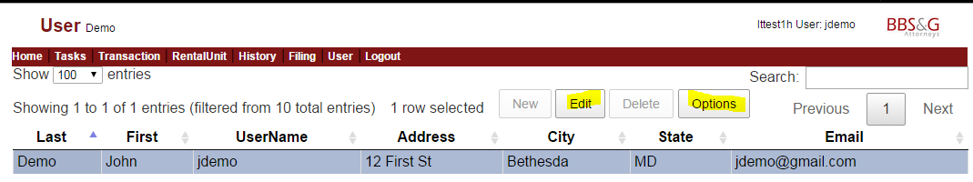

Figure 4

The Edit User screen allows you to update your information. Click Go to save your changes. Otherwise, click Cancel. You cannot change your Firm, Client, Property, or Role.

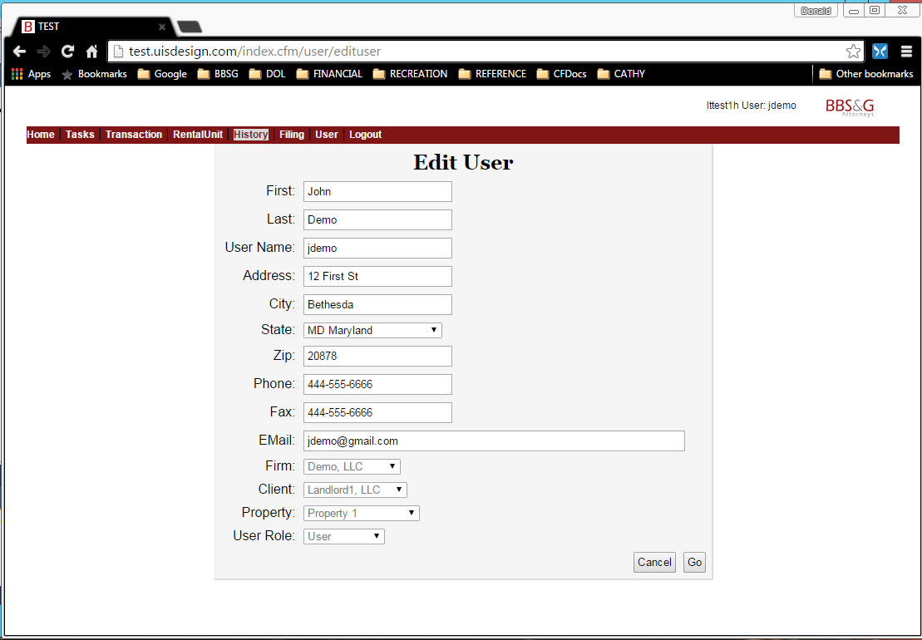

Figure 5

Clicking Options presents the following screen.

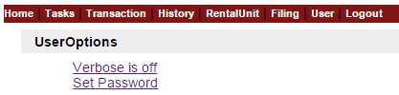

Figure 6

Clicking on “Verbose is off” will turn it on. You then will see “Verbose is on”. Clicking on that will turn it off. Verbose mode gives you an extra message when you change clients, properties, etc. Verbose mode is only useful when first learning to user LTWeb.

Set password allows you to change the password for the user, by entering the old password, and then a new password and a confirmation. Be sure to remember the new password, since there is no way to print it out.

# Filing

The Filing screen has the same general layout as many other LTWeb screens. After the screen title (“Filing”) is a “breadcrumb trail” showing how you got to this screen. Your login preselected the Client and Property for your LTWeb session. Your username appears at the top right.

Only the newest Filing is open (accepting new suit requests).

To select another filing, click on the **first** column in the row. For example, to select 4364, click on the 4456.

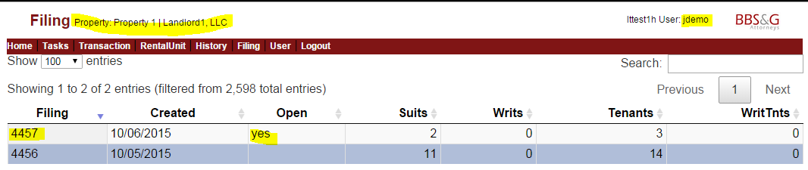Figure 7

You receive an alert saying you are changing to 4456.

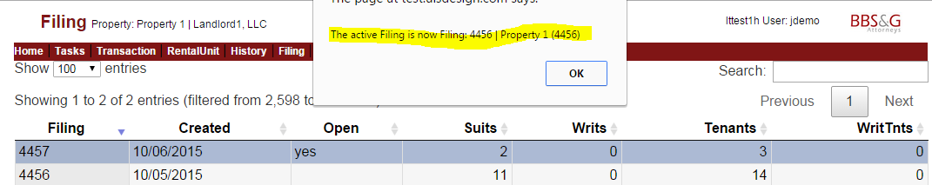

Figure 8

When you click OK on the alert, the 4456 row will be highlighted.

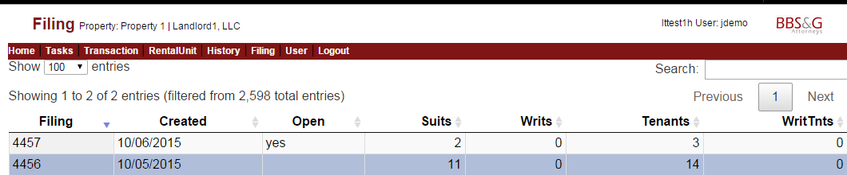

Figure 9

# RentalUnit – A Good Example of the LTWeb Controls

You will spend a large part of your LTWeb session in the RentalUnit Option. This contains a list of the rental units you have entered for your Property. The layout of this screen is similar to that of most of the other screens in LTWeb.

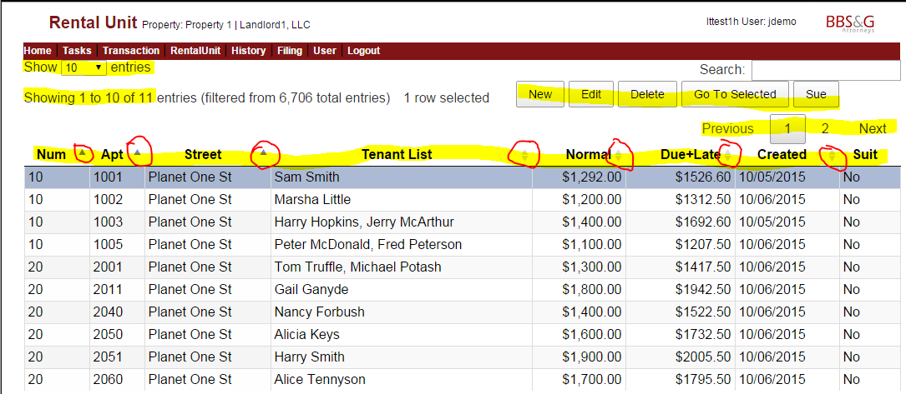

Figure 10

## Grouping Records

The left side of the heading (under **Home**) shows you are looking at the first group of 10 entries, out of 11 total for your property. Note that the terms “record”, “entry”, “rental unit”, and “unit” all mean the same thing.

You can change the number of rental units in a group, using the select box in the top left corner. You can navigate between groups of records with the Next… Prev controls on the right side of the header.

In general, having fewer records per group will mean faster response from the system, but having all the units in one group may be easier to use. With a good Internet connection and workstation, this might be your best option. You can select and change the group size whenever you want.

If you ever think something is missing, be sure to change to a large number of records per group, so you see everything.

## Searching

The right side has a powerful Search box – each letter you type will immediately search the **Num, Apt, Street, Tenant, Normal Rent, Due + Late, and Unit Create Date** (“Created”) columns in the list of units to narrow the list to match what you have typed. For example, typing “1003” will limit the list to records with “1003” in the Apt column.

If you are entering a new unit to sue, the Search provides a way to see if you have already sued other tenants at this address. If so, you can **Delete** the unit, and then **Add** it with the new tenants. This is necessary so that the calculation of judgement absolutes reflects the correct tenant list.

## Selecting

The blue highlighting in Figure 11 shows you have selected 10 Planet One St, apartment 1001.

You select a record on an LTWeb screen by clicking in the first column of that record - in this case, by clicking on the 10 in that record.

## Operating on a Record and Going to Selected

In the middle of the heading are options to

* **Add** a new rental unit (New)
* **Edit** the selected unit
* **Delete** the selected unit
* **Go to the Selected record**. This is the unit you highlighted. In this case, for example, if you move to the second group of records (records 11 to 11), and then click **Go To Selected**, you will return to the record you selected (“10 Planet One St, apartment 1001”). This can be a convenient alternative to scrolling a long list of records, or jumping between groups of records.
* **Sue** – Initiate a suit of the tenants in the selected unit (this is unique to the RentalUnit screen)

## Sorting

You can sort the records by clicking on the columns that have small indicators. The indicators are circled in Figure 11. In this example, there is an up-arrow to the right of Num, Street, and Apt. This means the current list is sorted from lowest to high on those fields. LTWeb has a special sort for these fields, which experience has shown is the most convenient. Clicking on any of these columns yields the same sort: Street, Street Number within Street, and Apt (apartment) within Street and Num.

Clicking a second time on one of the columns will reverse the order, so that the alphabetically highest street will show first (not necessarily a very useful option).

Looking at the right side of the next column in the example – Tenant List – we see a light-colored up and down arrow. This means the list is sortable on that column, but the list is not currently sorted on that column. So, clicking once on **Tenant List** will sort the records in order by the name of the first tenant. Clicking on **Tenant List** again will sort the records so that the “Z…” tenants appear first.

Other columns for sorting the list are Normal Rent, Due+Late amount, and Created. In particular, clicking on **Created** will present the records in the order you created the records. This can be useful when comparing the list of units to some other list you have of changes to be made.

(Similarly, you can click on the Creat column in the Transaction screen shown in Figure 17 – Transaction Screen to see the suits in the order they are created.)

## Initiating a Suit

The Sue Button – which is unique to the RentalUnit screen - allows initiating a Suit against the tenants in the selected RentalUnit. Clicking **Sue** will display a Suit Status message (Figure 12). Note that the Action number (TransID) always starts with the Filing number of the open filing..

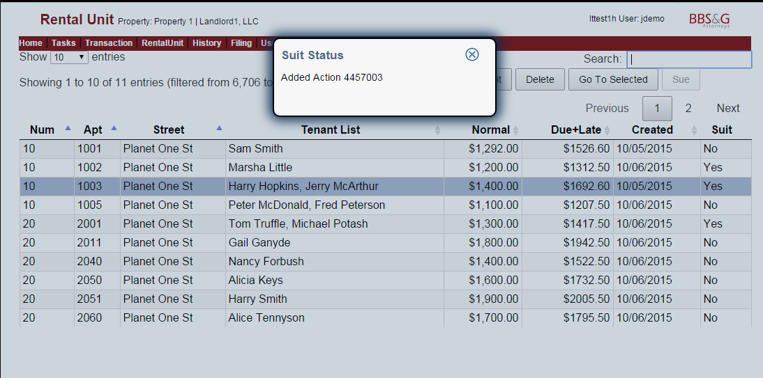

Figure 11

Note: if you need to make changes to any number (e.g. Rent Due) before suing, it is much easier to click **Edit**, make the changes, and click the **> Sue** checkbox in the Edit window, and click **Update** (see below).

## Editing

When you click **Edit**, a “bubble” pops up, with a header that confirms which unit you are editing.

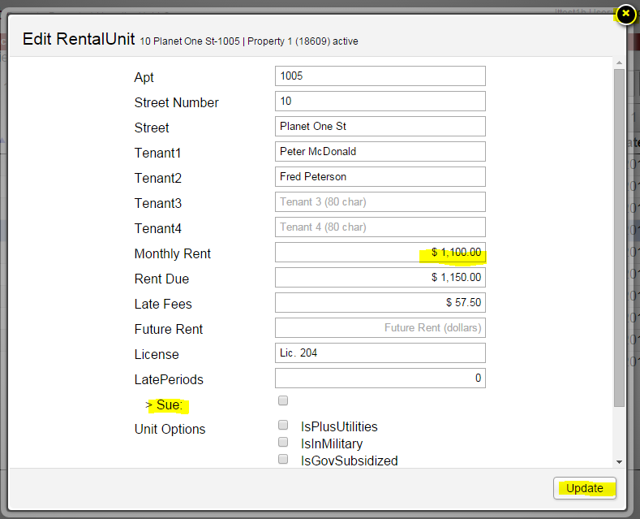

Figure 12

Enter your changes, and click **Update**.

If you do not click **Update**, no changes are made.

To close the bubble with making changes, click the **X** at the top right of the bubble.

To edit a money field, highlight the entire contents of the field, then type numbers and a decimal point. The $ and comma are maintained automatically. Note that if you Tab into the field, the entire contents are automatically highlighted for you.

When you enter Rent Due, LTWeb calculates Late Fees at 5%. **You can type over (change) this calculated number.**

To request a Suit be initiated against the tenants, click **> Sue** button before clicking **Update**.

# History

The History Option shows the suit history for the unit you select in the RentalUnit Option. For example, if you select the unit at 10 Planet One St – Apt 1003, then click **History**, you see

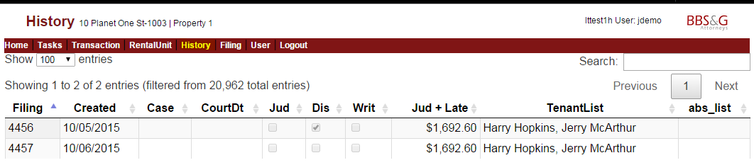

Figure 13

the suits related to the rental unit, with the filing, the date the suit was created, case number, court date, etc.

You check here to see what months have been sued, so you don’t sue twice for a particular month. Use this when you think there is more than one month owed.

# Transaction

The Transaction and Rental Unit screens are closely related. For example, if you use the Rental Unit screen to initiate a suit for a particular record in the current open Filing …

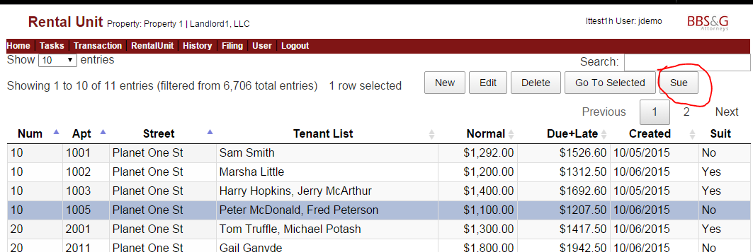

Figure 14

… and then click **Transaction**, and **Go To Selected**, you see the new suit. It is under the open Filing: 4457.

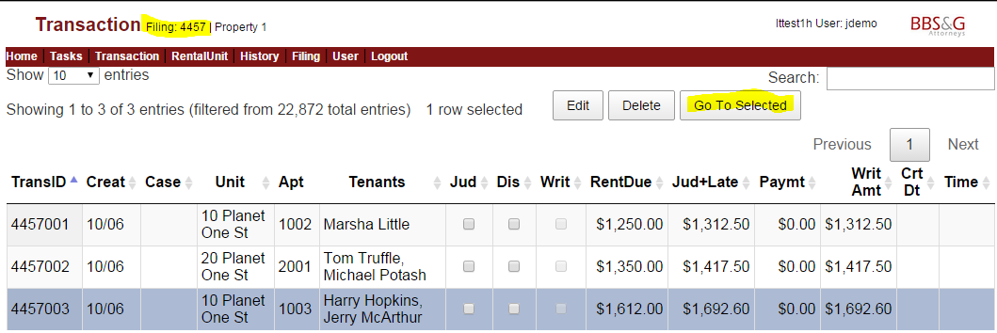

Figure 15

Another way to see the new suit in the Transaction Option is to click on the **Creat** column heading twice, invoking a sort, so that the most-recently-created suit is at the top of the list. (Note, **Creat** is an abbreviation for Created. LTWeb uses this abbreviation so that everything fits on the monitor at 1280 x 720 resolution).

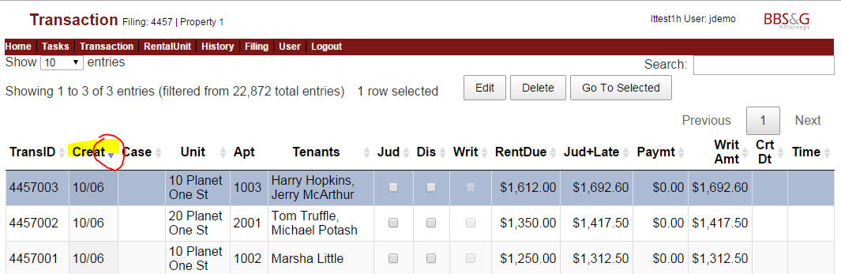

Figure 16 – Transaction Screen

**Court Preparation** - Up until 3 pm the day before a court date, a Client User can make changes in LTWeb – using the Transaction Menu Option to edit Transactions - reflecting **payments, partial payments, amended amounts, tenants vacating**, etc.

The Client User checks **Judgement** to indicate they are going forward with a Judgement, or clicks **Dismiss** to request that the case be dismissed.

The Client User should notify the Firm Administrator by phone or email when all changes are complete. The Administrator can then immediately print a new Docket and a new Dismissal Report, to interact with the Court.

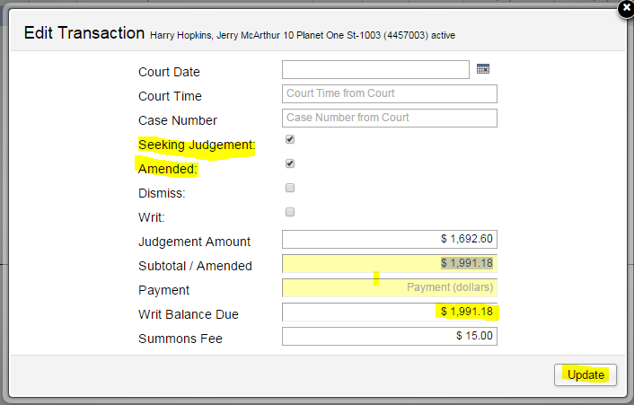

Figure 17

Typically, an LTWeb User clicks **Seeking Judgement** when it is decided to file the Complaint with the Court.

It the tenant has made a payment, or other arrangements, before the Complaint is to be sent to Court, the LTWeb User clicks **Amended**, and enters the new amount for the suit into the **Subtotal/Amended** field. At this point, the **Payment** field should be set to 0. The **Writ Balance** Due field is automatically calculated.

Whenever the **Amended** box is checked, the **Judgement/Amount** will show as amended in various reports, including the Docket.

As in all LTWeb screens, click **Update** to make the update “stick”, otherwise click the **X** at the top right of the bubble.

Alternatively, the LTWeb User might click **Dismiss**. The complaint will be deleted from Docket, and not sent to Court.

The Firm Administrator maintains the **Court Date**, **Court Time**, and **Case Number** fields.

# Task

When you use the Tasks Option, you will notice interactions between Task, Transaction, and Filing.

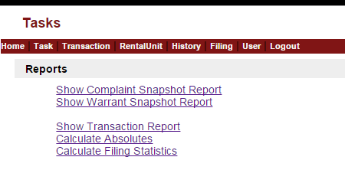

Figure 18

The first two reports are for a single Transaction you have selected under the Transaction Option.

On the other hand, the Transactions Report is for all the Transactions in the Filing you have selected.

Calculate Absolutes scans all the units in the current Filing, to ensure the calculations are up to date. This calculation is also automatically performed when the Firm Administrator Makes Warrants to send to the court.

The reports are shown below.

## Complaint Snapshot for a Rental Unit

This is the Complaint Snapshot for the Transaction with Transaction ID 4457003. This Transaction was selected under the Transaction Option, before the report was produced. It is a good review of what will be submitted to court on a Complaint form.

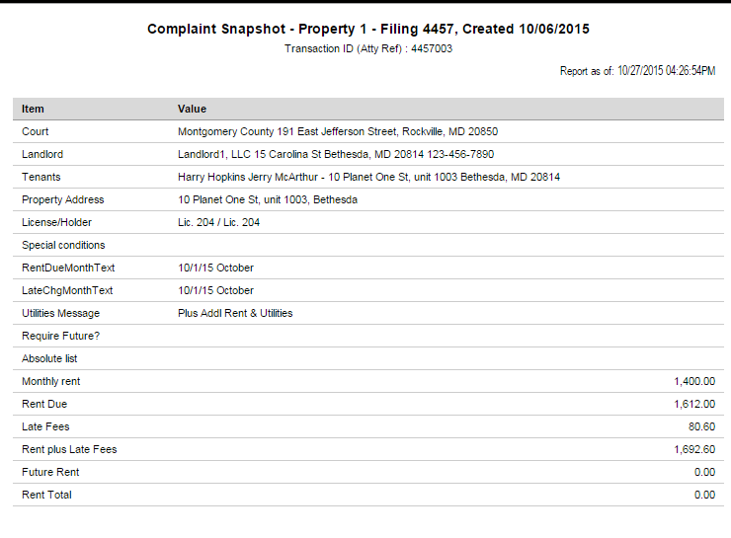

Figure 19

## Warrant Snapshot for a Rental Unit

This example shows the Warrant Snapshot for the Transaction with Transaction ID 4457003. This Transaction was selected under the Transaction Option, before the report was produced. It is a good review of what will be submitted to court on a Warrant form (Writ of Restitution).

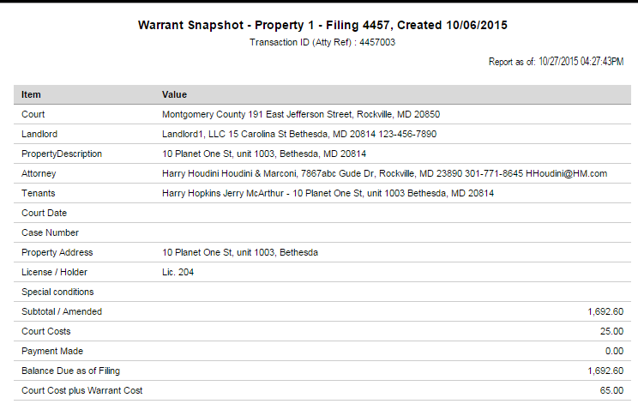

Figure 20

## Transactions Report

This report is very convenient for reviewing your data entry for a particular **Filing**, and to see history of units in the Filing, at any time before the Filing is used to file complaints or warrants with the court.

In the example, the rows are sorted by Case Number, because the user sorted the Transactions under the Transactions Option by Case Number before producing this report. Note that unit and tenant counts are given at the top of the report. If an amount has been changed since the original Transaction was created, and marked “Amended”, the new amount is flagged with an asterisk.

When the report is sorted by CaseNum, if there is a break in the sequence of case numbers, “*SQ” is appended to the case number. If there is a missing Case Number, it shows as BLANK.

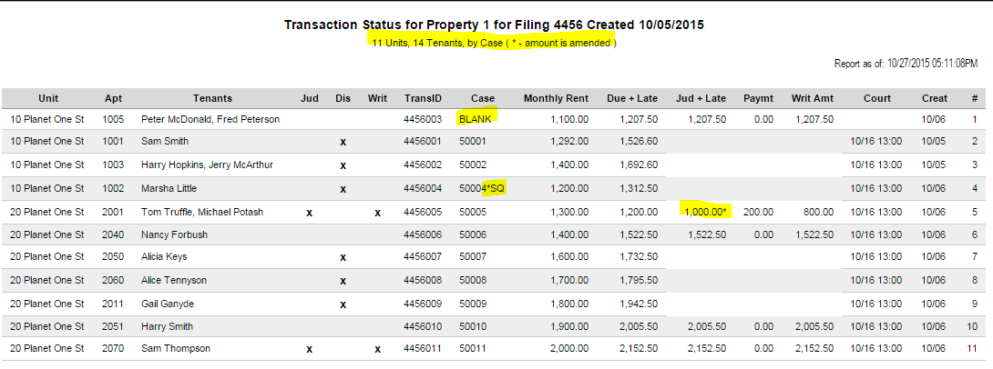

Figure 21